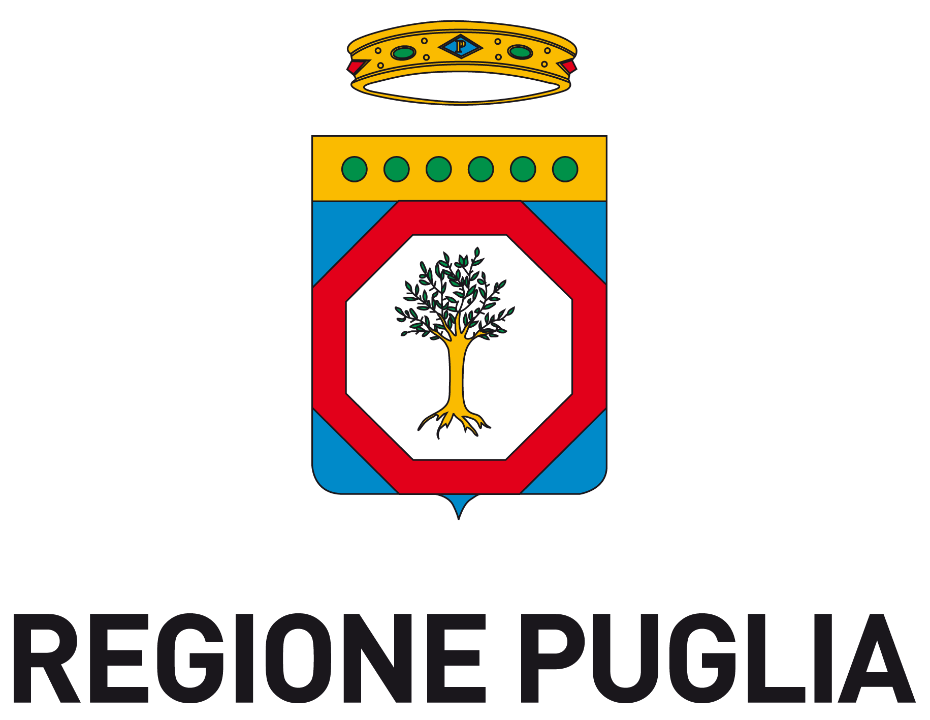

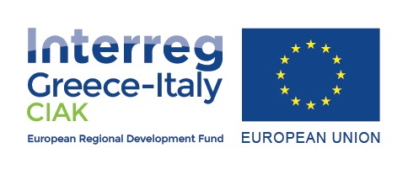

PUBLIC CALL RELATED TO A MARKET SURVEY FOR THE EXECTUTIVE PRODUCTION OF
10 FICTION SHORT MOVIES IN THE FRAME OF PILOT ACTION “MEMORY” (WP3) OF CIAK PROJECT, FINANCED UNDER INTERREG CBC PROGRAMME GREECE-ITALY 2014/2020
CUP B99D17019490007

Annex 2

ECONOMIC OFFER

Fac-simile

Spett.le
Fondazione Apulia Film Commission
Cineporti di Puglia/Bari c/o Fiera del Levante,
Lungomare Starita, 1 - 70132 Bari

PUBLIC CALL RELATED TO A MARKET SURVEY FOR THE EXECTUTIVE PRODUCTION OF 10 FICTION SHORT MOVIES IN THE FRAME OF PILOT ACTION “MEMORY” (WP3) OF CIAK PROJECT, FINANCED UNDER INTERREG CBC PROGRAMME GREECE-ITALY 2014/2020
(CUP B99D17019490007)

DECLARATION OF ECONOMIC OFFER
The undersigned ____________, born in _________ on ____________ fiscal code no. __________________, in the capacity of __________________________ and legal representative of ____________________________, with registered office in ______________, Address _______________________, fiscal code (only for Italian-based economic operators) no. _________________________, VAT no. ___________________, in order to participate to the public call, offers the following price (VAT excluded, any other tax/fee included) . TOTAL PRICE OFFERED (IN FIGURES AND LETTERS):

€ ____________________

EURO _____________/__

(N.B.: the price cannot be higher than euro 24.000,00)

The undersigned also declares to accept all the conditions specified in the public call and also declares:
- that this offer will not bind Apulia Film Commission Foundation in any way;
- to acknowledge all the general and special circumstances that may affect the execution of all the performances subject to the contract and to have taken into account these circumstances to determine the compensation required, considered profitable.

Place_________________, date _____________________
Signature

__________________________

